Step 1: installing Jenkins as a tomcat application
- Install java 11
- amazon-linux-extras install java-openjdk11 -y
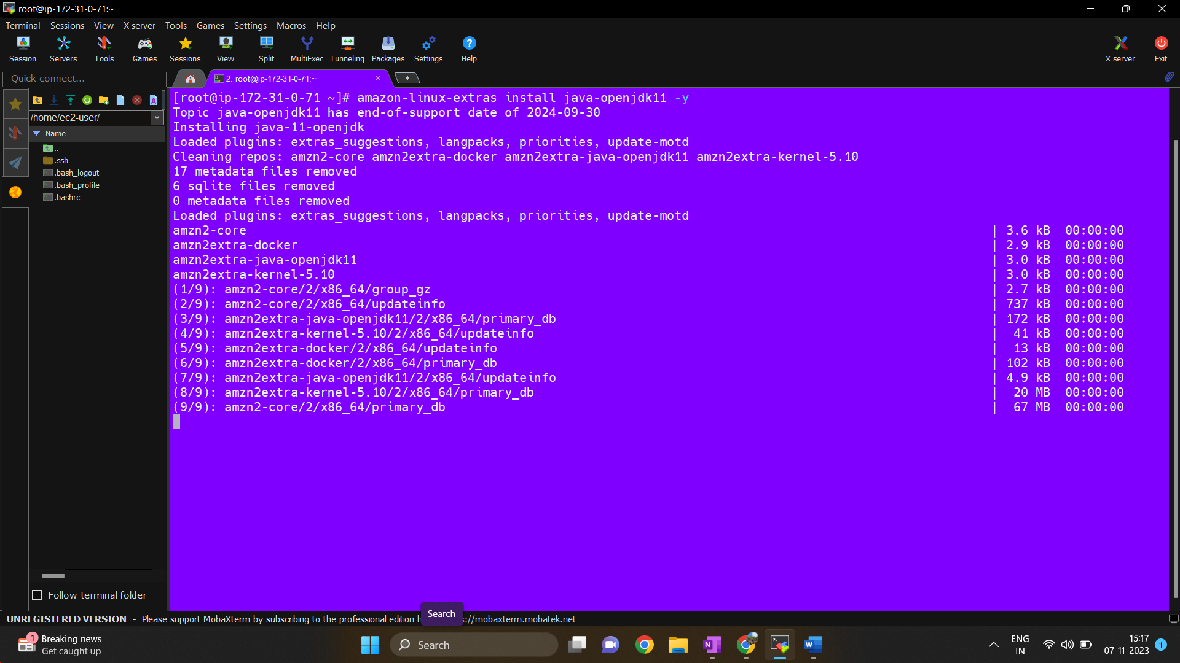
- Download a Tomcat Zip file > Unzip the file
- wget https://dlcdn.apache.org/tomcat/tomcat-9/v9.0.82/bin/apache-tomcat-9.0.82.zip
- unzip apache-tomcat-9.0.82.zip
- chmod -R 777 apache-tomcat-9.0.82/
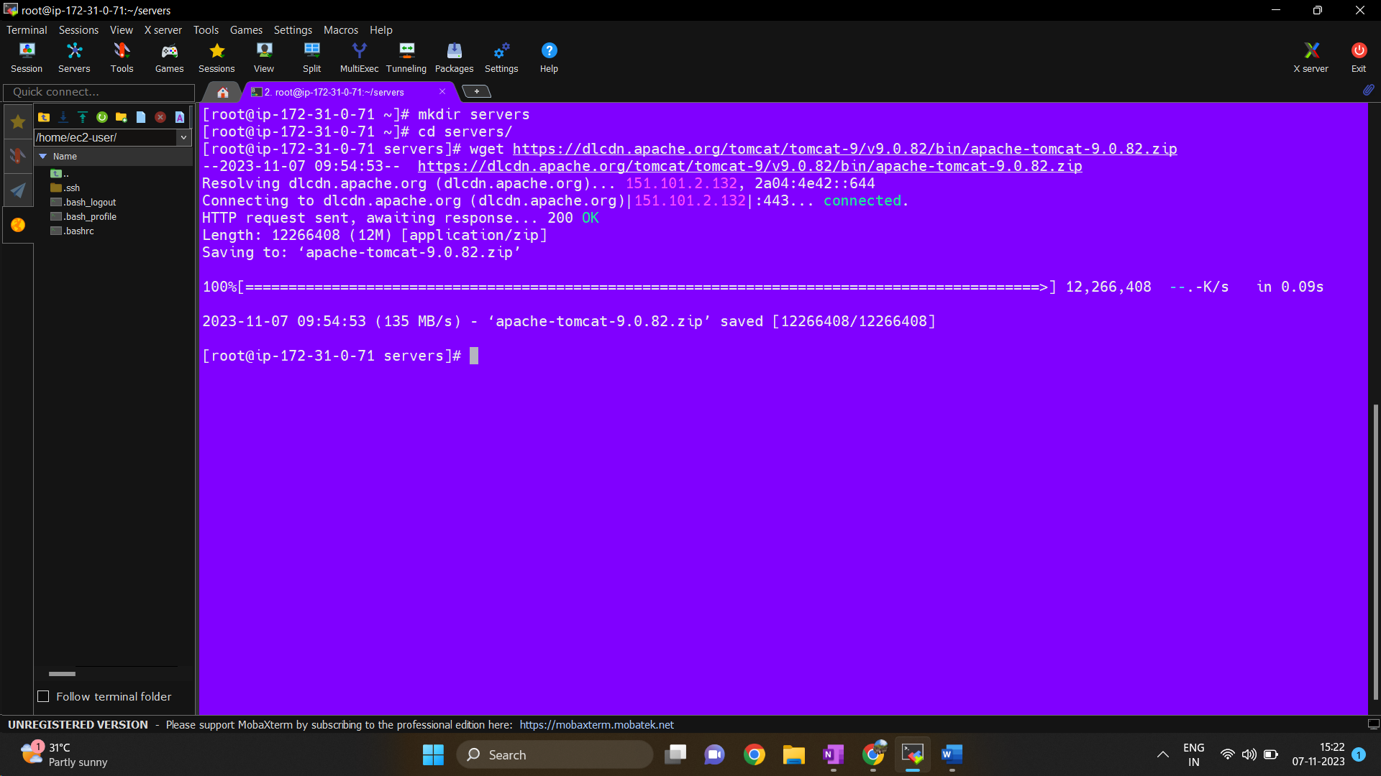
- Deploy Jenkins war file inside webapps folder.
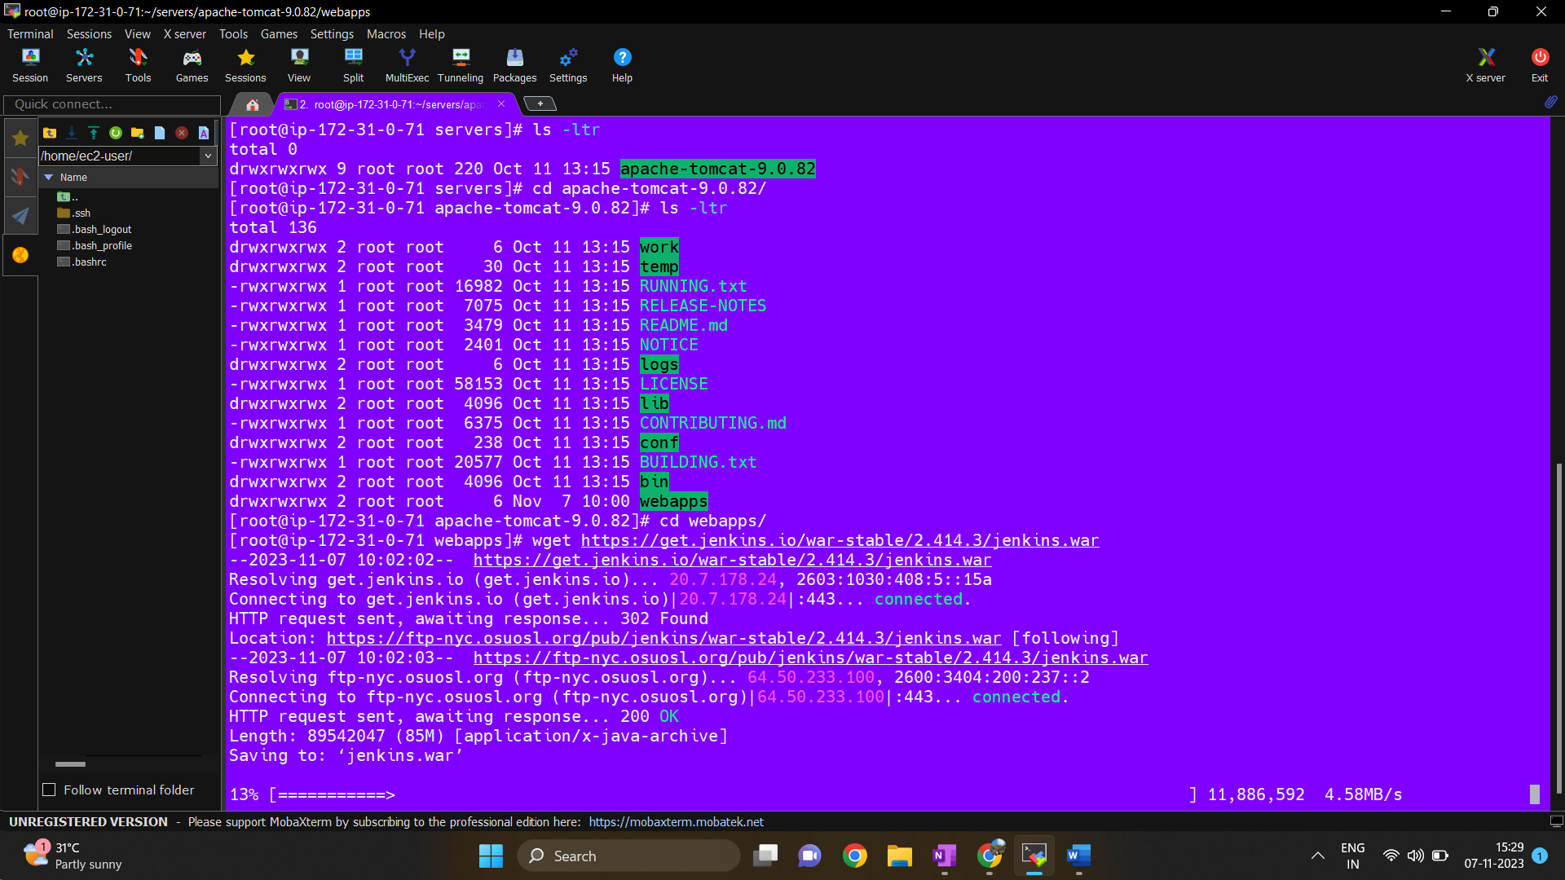
4.Go to /root/servers/apache-tomcat-9.0.82/bin folder and run ./startup.sh file.
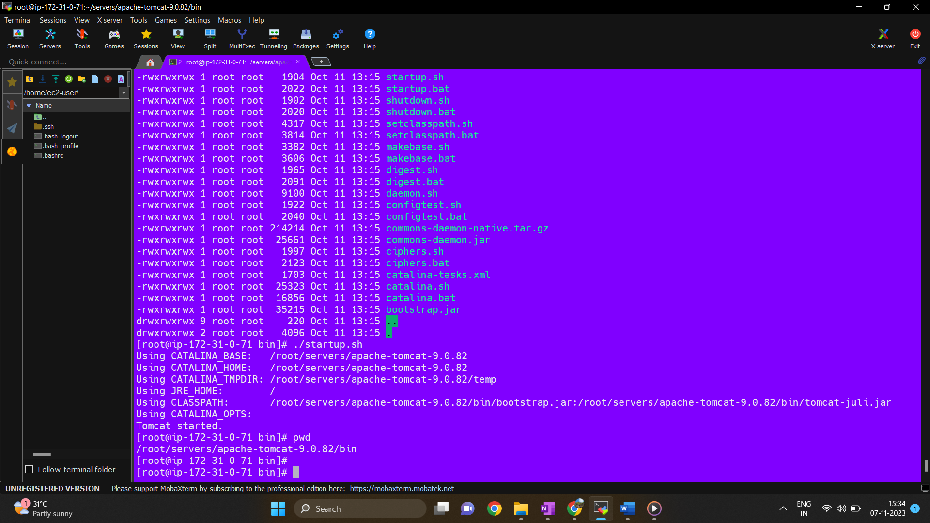
- To check logs go to /root/servers/apache-tomcat-9.0.82/logs folder and read catalina.out
- tail -100f catalina.out
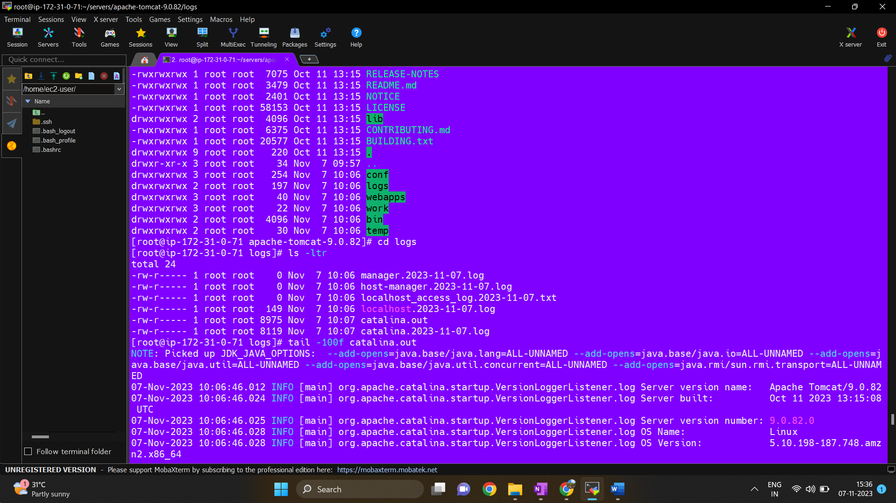
- Jenkins Home: /root/.jenkins

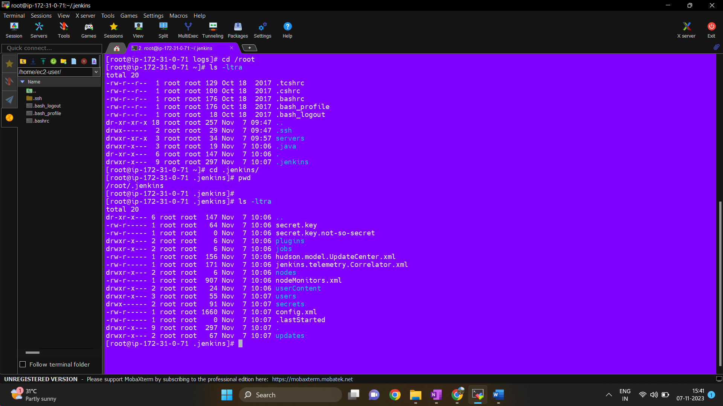

- Accessing Jenkins UI > Read the file using cat command for initial password.
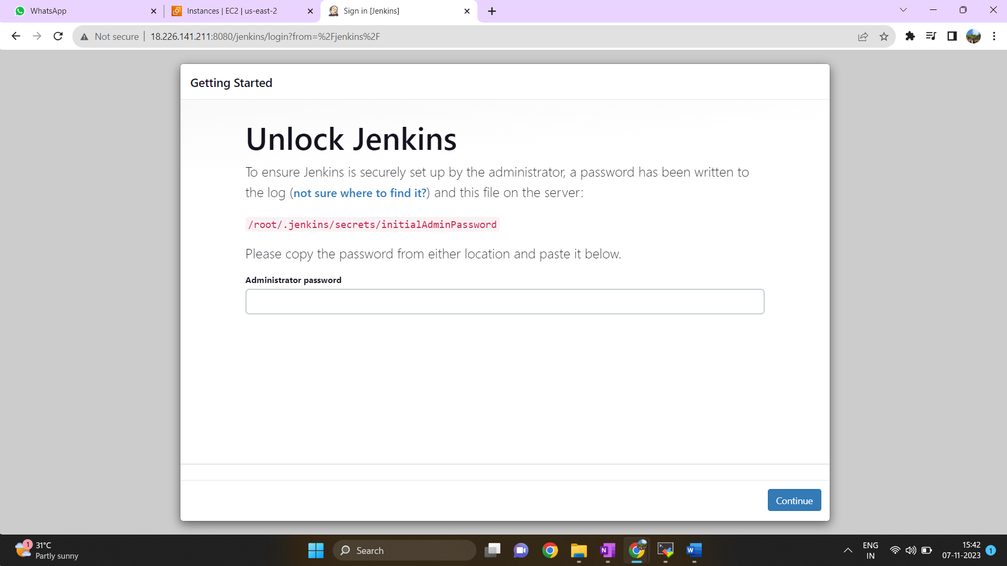

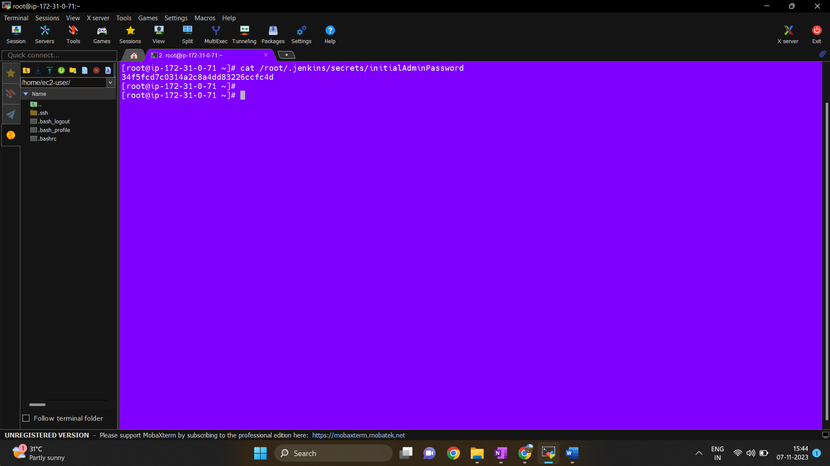

- Use this password to getting start with Jenkins.
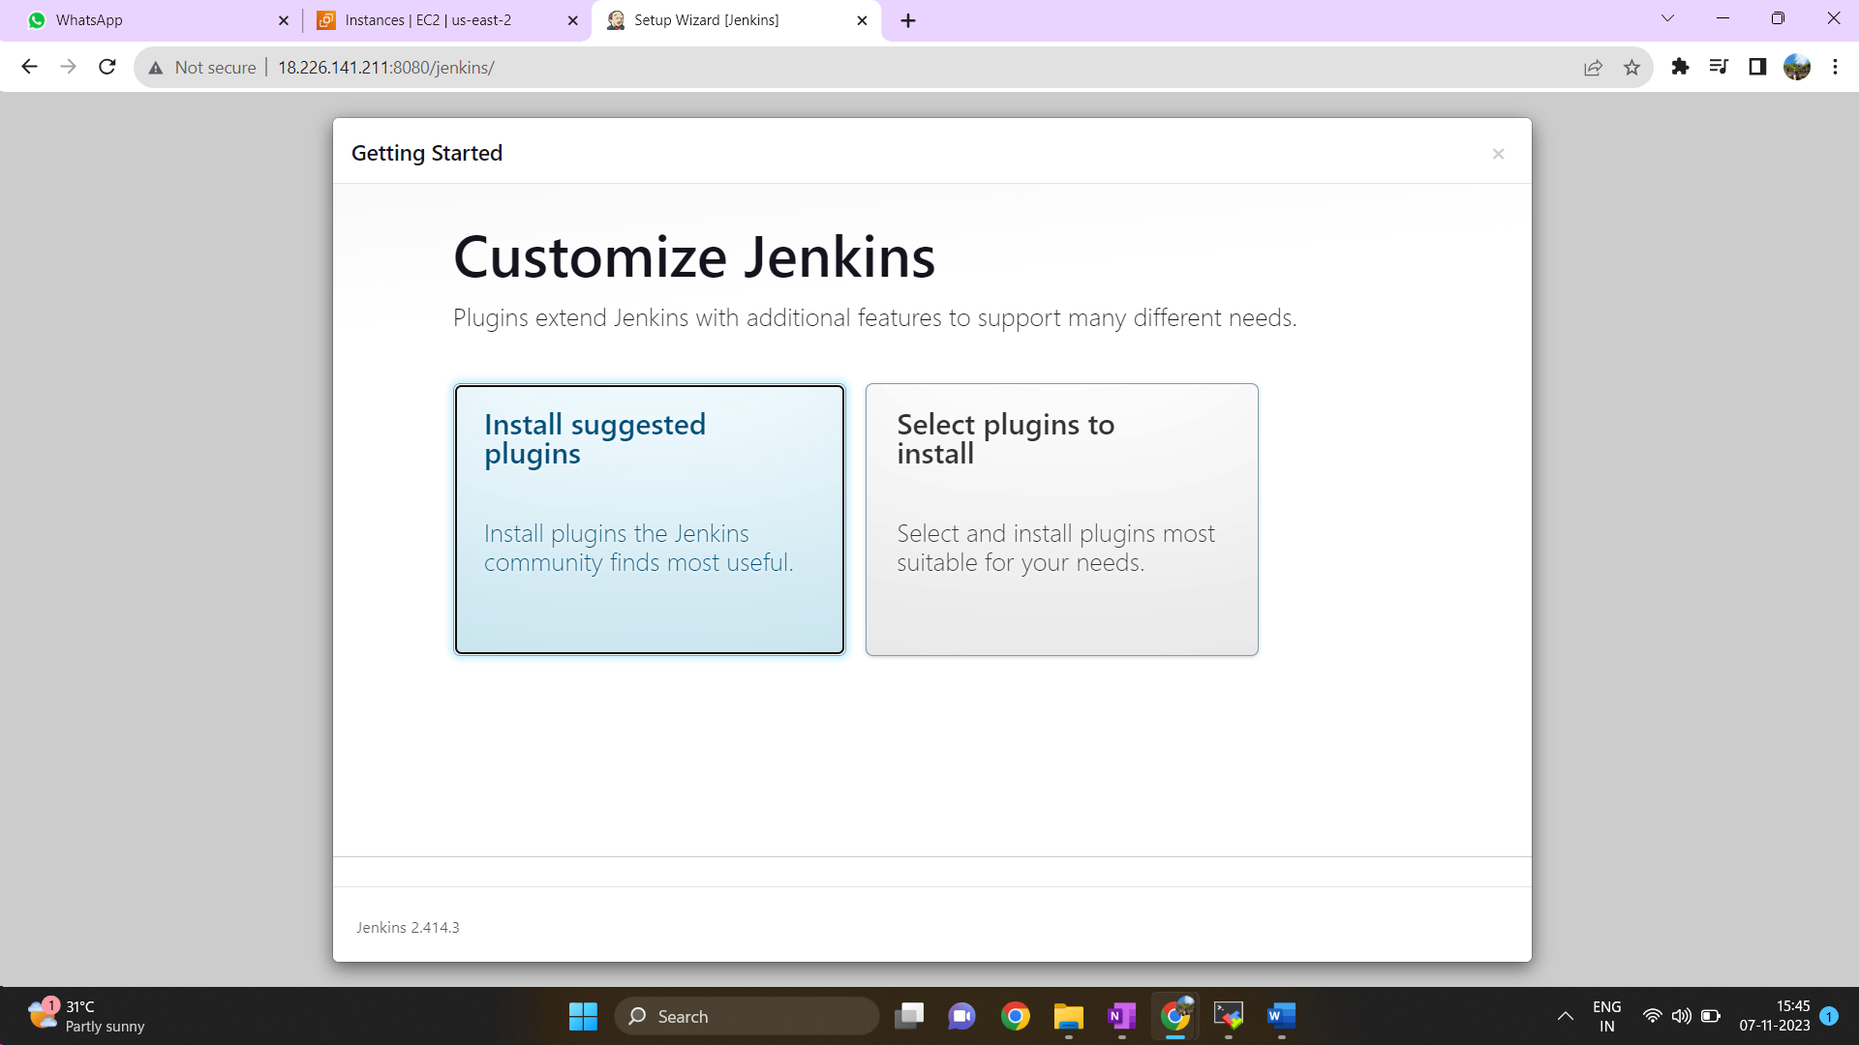

- Installed suggested Plugin

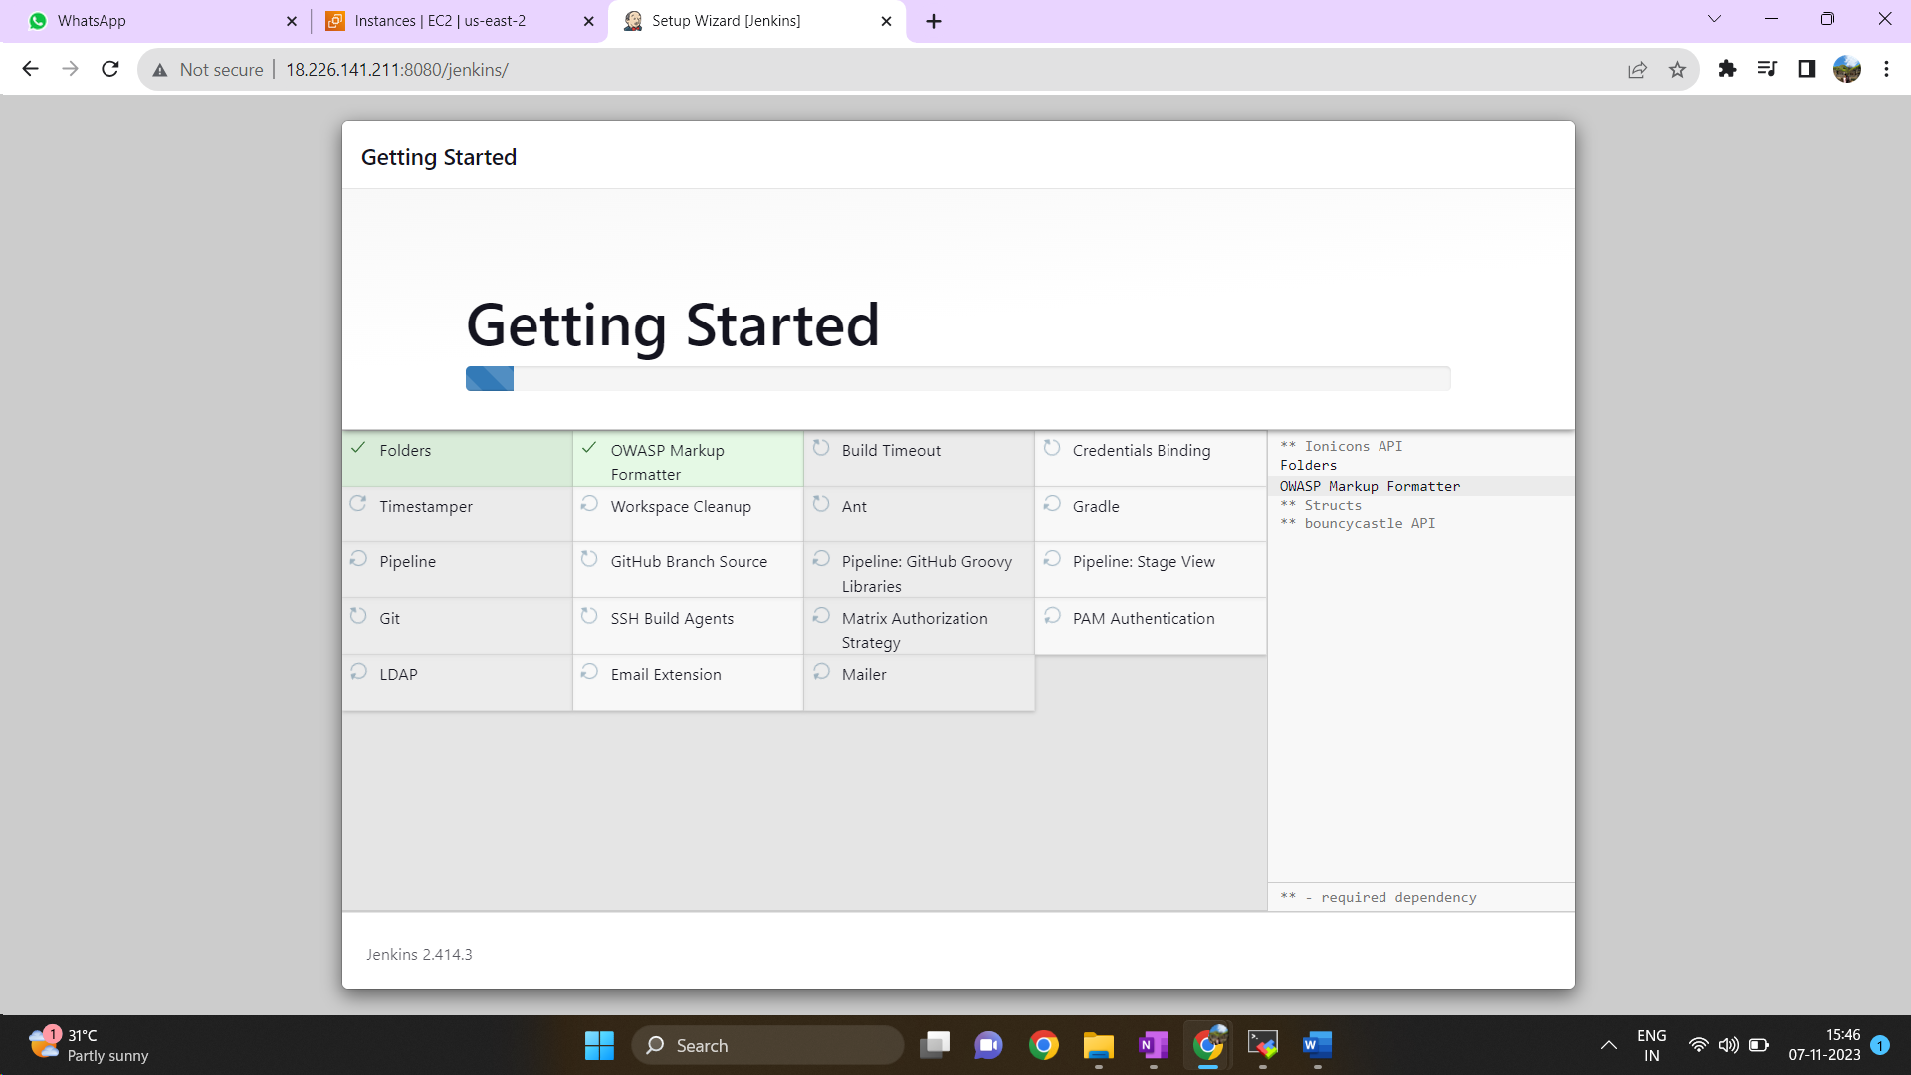

- Create First Admin User
